Day 4: Gate-Level Simulation (GLS), Blocking vs. Non-Blocking in Verilog, and Synthesis-Simulation Mismatch
- Gate-Level Simulation (GLS)
- Blocking vs. Non-Blocking Assignments in Verilog
- Synthesis-Simulation Mismatch

Table of Contents
- 1. Gate-Level Simulation (GLS)
- 2. Synthesis-Simulation Mismatch
- 3. Blocking vs. Non-Blocking Assignments in Verilog
  - 3.1 Blocking Statements
  - 3.2 Non-Blocking Statements
  - 3.3 Comparison Table
- 4. Labs
- 5. Summary

1. Gate-Level Simulation (GLS)
GLS stands for Gate-Level Simulation. It is a critical verification step in the VLSI design flow where the synthesized gate-level netlist of a digital circuit is simulated to validate:
- Functional correctness
- Timing behavior
- Power estimates
- Test structures (e.g., scan chains for DFT)
Why Perform GLS?
- Synthesis Validation: Ensures that synthesis tools faithfully translate RTL into gates.
- Timing Verification: Simulates with realistic delays (from SDF files), allowing you to check for timing violations (e.g., setup/hold errors).
- Testability: Confirms that scan chains and other test features work post-synthesis.
When is GLS Performed?
- After synthesis: Once the RTL is converted into a gate-level netlist.
- Before physical design: To catch issues early, before layout.
Types of GLS
- Functional GLS: Logic-only simulation, often with zero or unit delays.
- Timing GLS: Uses annotated timing data to check real-world timing behavior.

2. Synthesis-Simulation Mismatch
A synthesis-simulation mismatch occurs when the simulation results of RTL (pre-synthesis) do not match simulation results of the gate-level netlist (post-synthesis) or hardware. Reasons include:
- Non-synthesizable constructs: Use of delays, initial blocks, or other code not supported by synthesis.
- Incomplete or ambiguous coding: E.g., missing else clauses, improper sensitivity lists.
- Tool interpretation differences: Simulation and synthesis tools may interpret ambiguous RTL differently.
Key Point: Always write synthesizable, unambiguous RTL and follow good coding practices to minimize mismatches.

3. Blocking vs. Non-Blocking Assignments in Verilog
Verilog offers two types of procedural assignments:
3.1 Blocking Statements (=)
- Syntax: =
- Execution: Sequential, executes immediately.
- Suitable for: Combinational logic (e.g., always @(*)).
- Example:
always @(*) y = a & b;
3.2 Non-Blocking Statements (<=)
- Syntax: <=
- Execution: Scheduled, executes concurrently at the end of the time step.
- Suitable for: Sequential logic (e.g., always @(posedge clk)).
- Example:
always @(posedge clk) q <= d;
3.3 Comparison Table
Blocking (=) | Non-Blocking (<=)
Uses = operator | Uses <= operator
Sequential, immediate execution | Concurrent, scheduled at end of timestep
Updates happen instantly in code order | Updates applied after time step
For combinational logic, temp variables | For sequential logic, registers/flip-flops
Infers combinational logic (gates) | Infers sequential logic (flip-flops)

4. Labs
Lab 1: Ternary Operator MUX
Verilog code for a simple 2:1 multiplexer using a ternary operator:
module ternary_operator_mux (input i0, input i1, input sel, output y);
assign y = sel ? i1 : i0;
endmodule
- Function: y = i1 if sel = 1; else y = i0.
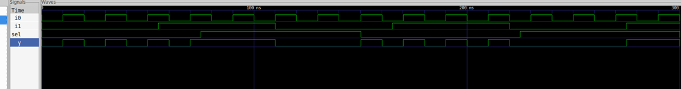

Lab 2: Synthesis Using Yosys
Synthesize the above MUX using Yosys.
Follow the standard Yosys synthesis flow.
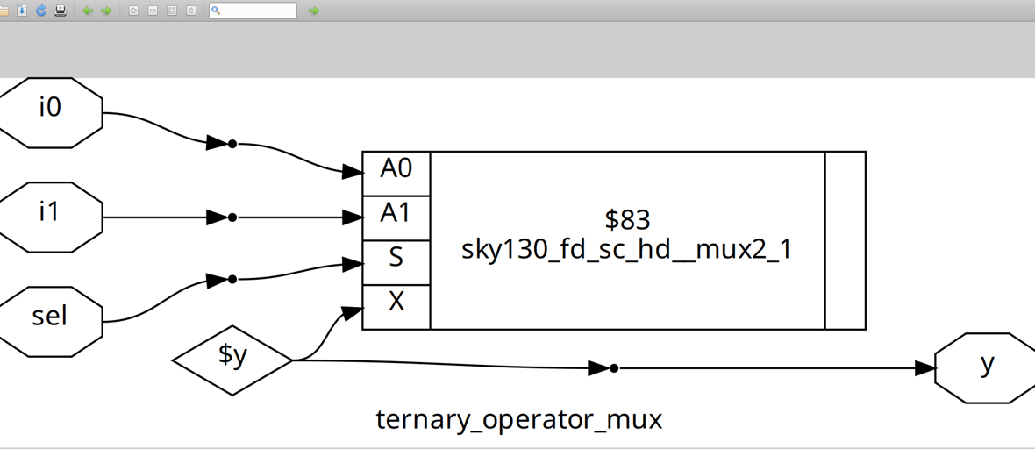
Lab 3: Gate-Level Simulation (GLS) of MUX
Run GLS for the synthesized MUX.
Use this command (adjust paths as needed):
iverilog /path/to/primitives.v /path/to/sky130_fd_sc_hd.v ternary_operator_mux.v testbench.v
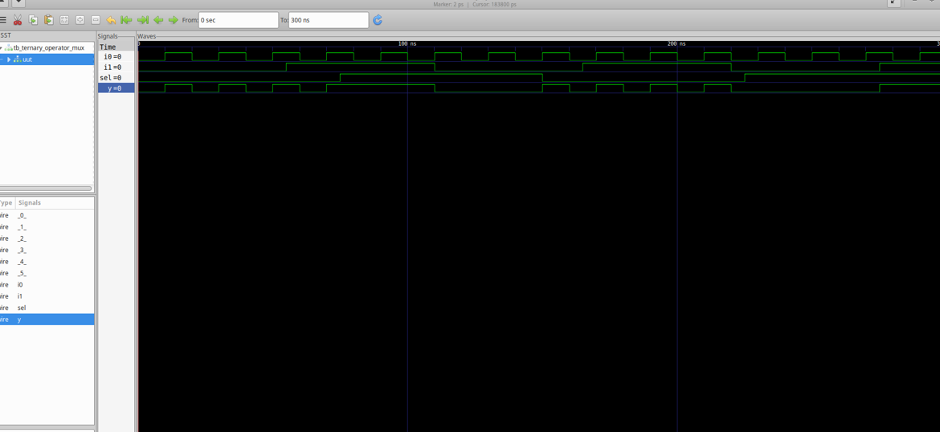

Lab 4: Bad MUX Example (Common Pitfalls)
Verilog code with intentional issues:
module bad_mux (input i0, input i1, input sel, output reg y);
always @ (sel) begin
if (sel)
y <= i1;
else
y <= i0;
end
endmodule
Issues:
- Incomplete sensitivity list: Should include i0, i1, and sel.
- Non-blocking assignment in combinational logic: Should use blocking assignments (=).
Corrected version:
always @ (*) begin
if (sel)
y = i1;
else
y = i0;
end
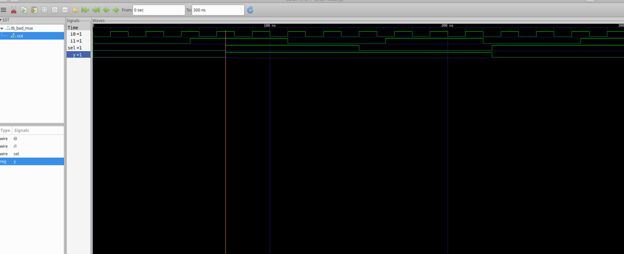

Lab 5: GLS of Bad MUX
Perform GLS on the bad_mux.
Expect simulation mismatches or warnings due to above issues.
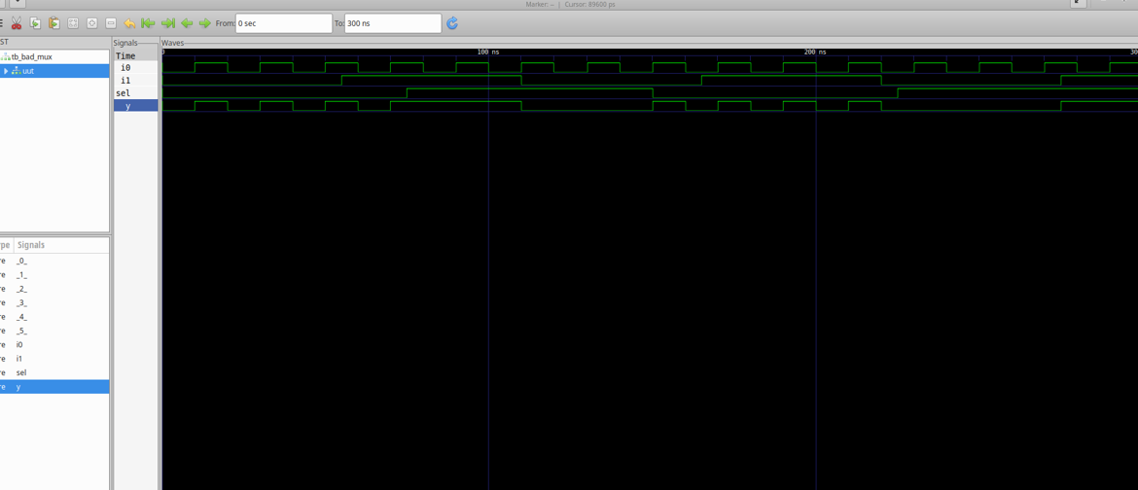
Lab 6: Blocking Assignment Caveat
Verilog code:
module blocking_caveat (input a, input b, input c, output reg d);
reg x;
always @ (*) begin
d = x & c;
x = a | b;
end
endmodule
What’s wrong?
- The order of assignments causes d to use the old value of x—not the newly computed value.
- Best Practice: Assign intermediate variables before using them.
Corrected order:
always @ (*) begin
x = a | b;
d = x & c;
end
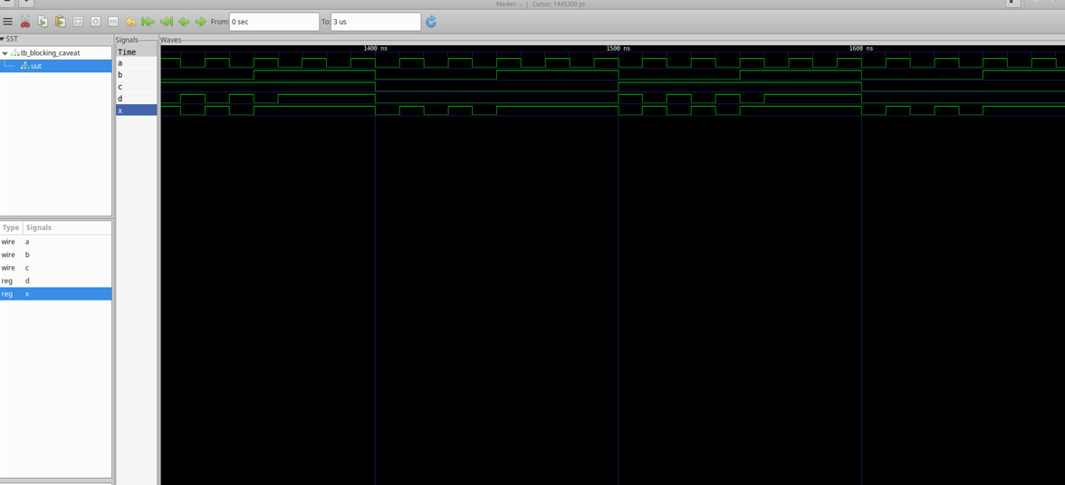

Lab 7: Synthesis of the Blocking Caveat Module
Synthesize the corrected version of the module and observe the results.
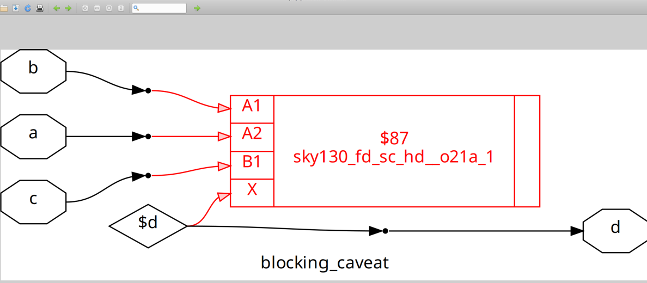
5. Summary
- Gate-Level Simulation (GLS): Validates netlist functionality, timing, and testability after synthesis.
- Synthesis-Simulation Mismatch: Avoid by using synthesizable, unambiguous RTL code.
- Blocking vs. Non-Blocking: Use blocking (=) for combinational, non-blocking (<=) for sequential logic.
- Labs: Reinforce key concepts and highlight common RTL pitfalls.

Day 5: Optimization in Synthesis

Contents
- 1. If-Else Statements in Verilog
- 2. Inferred Latches in Verilog
- 3. Labs for If-Else and Case Statements
  - Lab 1: Incomplete If Statement
  - Lab 2: Synthesis Result of Lab 1
  - Lab 3: Nested If-Else
  - Lab 4: Synthesis Result of Lab 3
  - Lab 5: Complete Case Statement
  - Lab 6: Synthesis Result of Lab 5
  - Lab 7: Incomplete Case Handling
  - Lab 8: Partial Assignments in Case
- 4. For Loops in Verilog
- 5. Generate Blocks in Verilog
- 6. What is an RCA (Ripple Carry Adder)?
- 7. Labs on Loops and Generate Blocks
  - Lab 9: 4-to-1 MUX Using For Loop
  - Lab 10: 8-to-1 Demux Using Case
  - Lab 11: 8-to-1 Demux Using For Loop
  - Lab 12: 8-bit Ripple Carry Adder with Generate Block
- Summary

1. If-Else Statements in Verilog
If-else statements are used for conditional execution in behavioral modeling, typically within procedural blocks (always, initial, tasks, or functions).
Syntax
if (condition) begin
// Code block executed if condition is true
end else begin
// Code block executed if condition is false
end
- condition: An expression evaluating to true (non-zero) or false (zero).
- begin ... end: Used to group multiple statements. Omit if only one statement is present.
- The else part is optional.
Nested If-Else
if (condition1) begin
// Code for condition1 true
end else if (condition2) begin
// Code for condition2 true
end else begin
// Code if no conditions are true
end

2. Inferred Latches in Verilog
Inferred latches occur when a combinational logic block does not assign a value to a variable in all possible execution paths. This causes the synthesis tool to infer a latch, which may not be the designer’s intention.
Example of Latch Inference
module ex (
input wire a, b, sel,
output reg y
);
always @(a, b, sel) begin
if (sel == 1'b1)
y = a; // No 'else' - y is not assigned when sel == 0
end
endmodule
Problem: When sel is 0, y is not assigned, so a latch is inferred.
Solution: Add Else or Default Case
module ex (
input wire a, b, sel,
output reg y
);
always @(a, b, sel) begin
case(sel)
1'b1 : y = a;
default : y = 1'b0; // Default assignment
endcase
end
endmodule

3. Labs for If-Else and Case Statements
Lab 1: Incomplete If Statement
module incomp_if (input i0, input i1, input i2, output reg y);
always @(*) begin
if (i0)
y <= i1;
end
endmodule

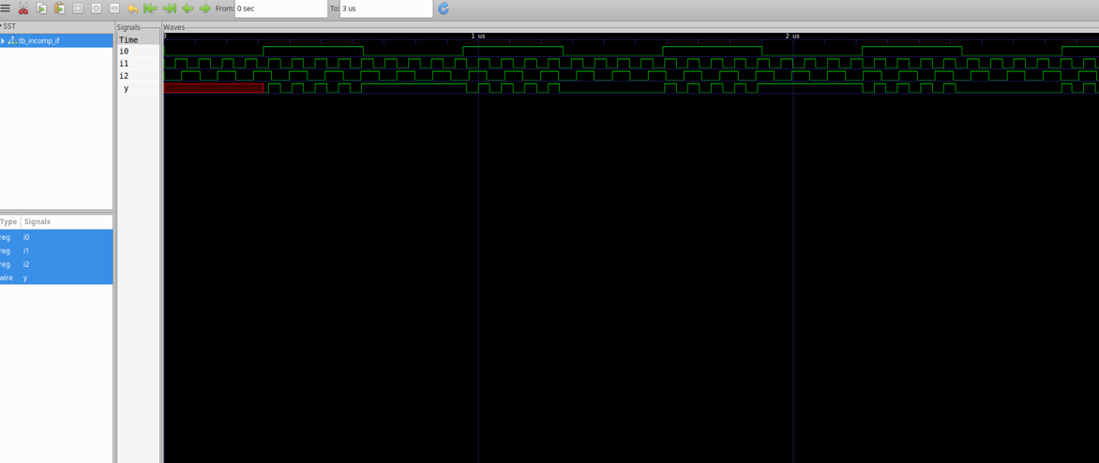
Lab 2: Synthesis Result of Lab 1
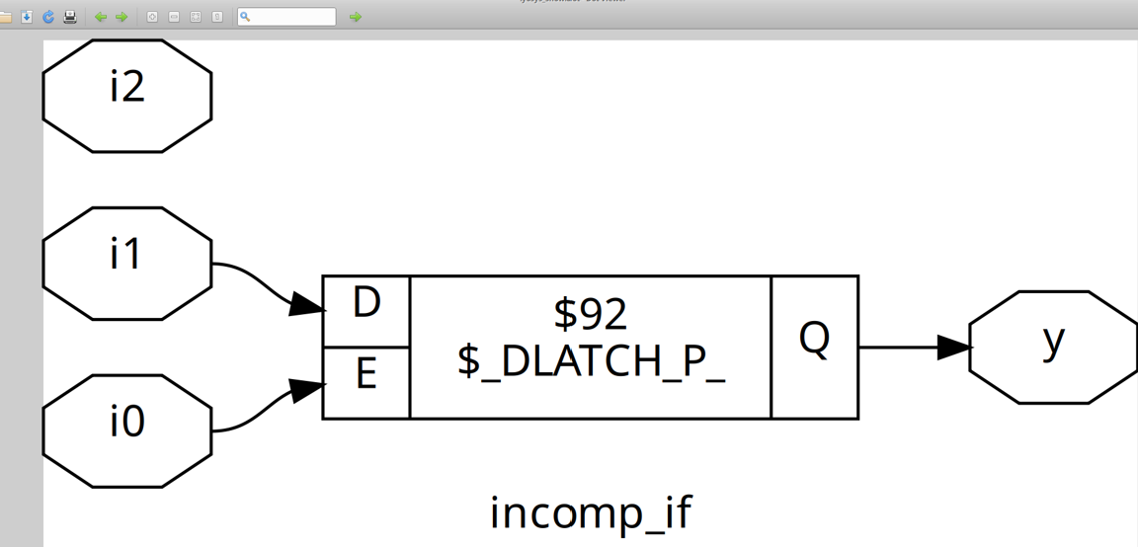
Lab 3: Nested If-Else
module incomp_if2 (input i0, input i1, input i2, input i3, output reg y);
always @(*) begin
if (i0)
y <= i1;
else if (i2)
y <= i3;
end
endmodule
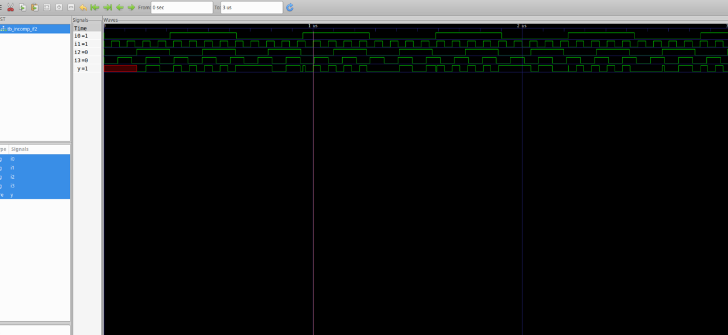

Lab 4: Synthesis Result of Lab 3
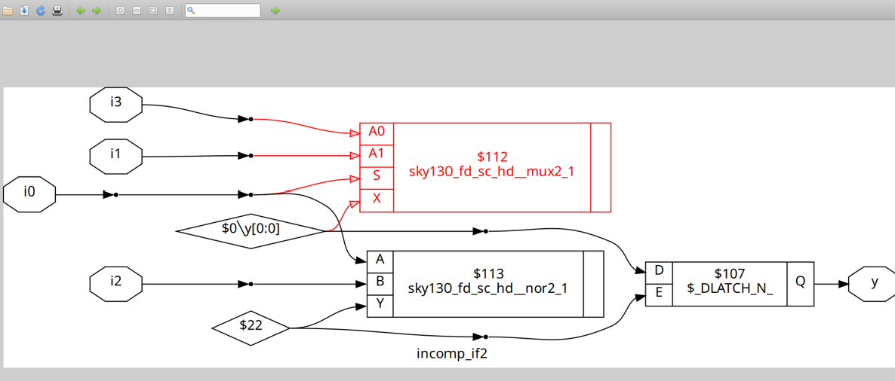

Lab 5: Complete Case Statement
module comp_case (input i0, input i1, input i2, input [1:0] sel, output reg y);
always @(*) begin
case(sel)
2'b00 : y = i0;
2'b01 : y = i1;
default : y = i2;
endcase
end
endmodule
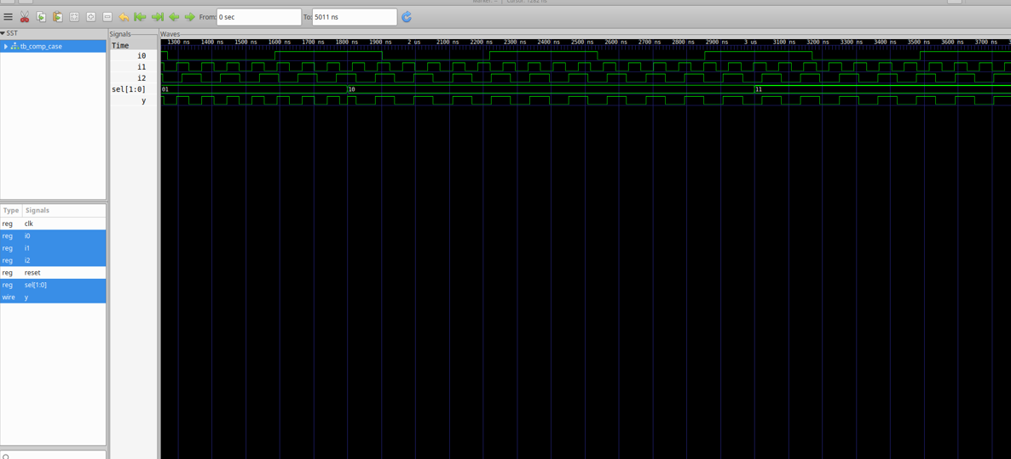
Lab 6: Synthesis Result of Lab 5
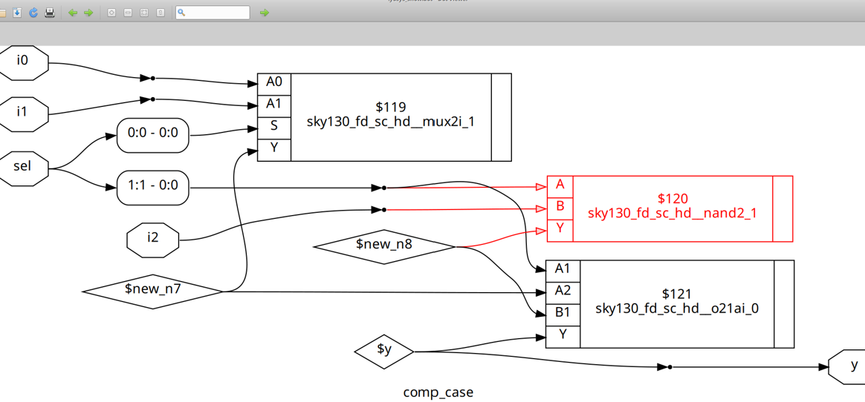
Lab 7: Incomplete Case Handling
module bad_case (
input i0, input i1, input i2, input i3,
input [1:0] sel,
output reg y
);
always @(*) begin
case(sel)
2'b00: y = i0;
2'b01: y = i1;
2'b10: y = i2;
2'b1?: y = i3; // '?' is a wildcard; be careful with incomplete cases!
endcase
end
endmodule

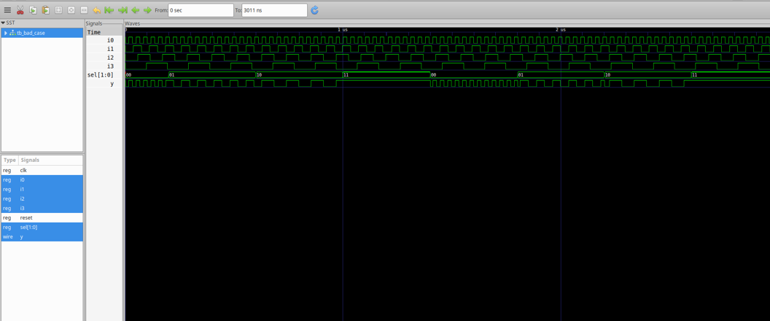
Lab 8: Partial Assignments in Case
module partial_case_assign (
input i0, input i1, input i2,
input [1:0] sel,
output reg y, output reg x
);
always @(*) begin
case(sel)
2'b00: begin
y = i0;
x = i2;
end
2'b01: y = i1;
default: begin
x = i1;
y = i2;
end
endcase
end
endmodule
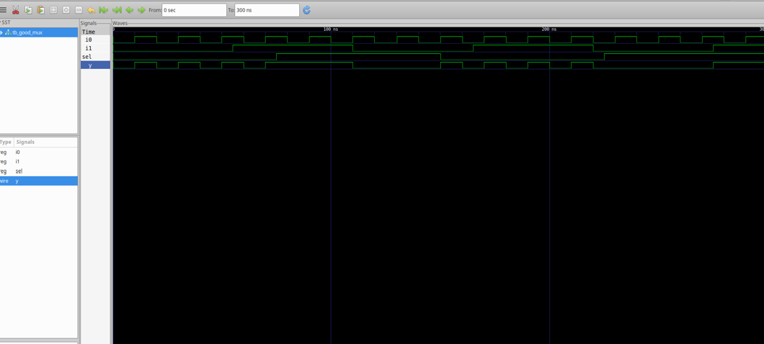
Note: Steps to perform the above labs are shown in Day 1.
4. For Loops in Verilog
A for loop is used within procedural blocks (initial, always, tasks/functions) to execute statements multiple times based on a loop counter.
Syntax
for (initialization; condition; increment) begin
// Statements to execute
end
- Must be inside procedural blocks.
- Synthesizable only if the number of iterations is fixed at compile time.
Example: 4-to-1 MUX Using a For Loop
module mux_4to1_for_loop (
input wire [3:0] data, // 4 input lines
input wire [1:0] sel, // 2-bit select
output reg y // Output
);
integer i;
always @(data, sel) begin
y = 1'b0; // Default output
for (i = 0; i < 4; i = i + 1) begin
if (i == sel)
y = data[i];
end
end
endmodule

5. Generate Blocks in Verilog
A generate block is used to create hardware structures such as module instances or logic at compile time. Typically used with for loops and the genvar keyword.
Example
genvar i;
generate
for (i = 0; i < 4; i = i + 1) begin : gen_loop
and_gate and_inst (.a(in[i]), .b(in[i+1]), .y(out[i]));
end
endgenerate

6. What is an RCA (Ripple Carry Adder)?
An RCA adds binary numbers using a chain of full adders. To add n bits, you need n full adders. Each carry-out connects to the carry-in of the next stage.
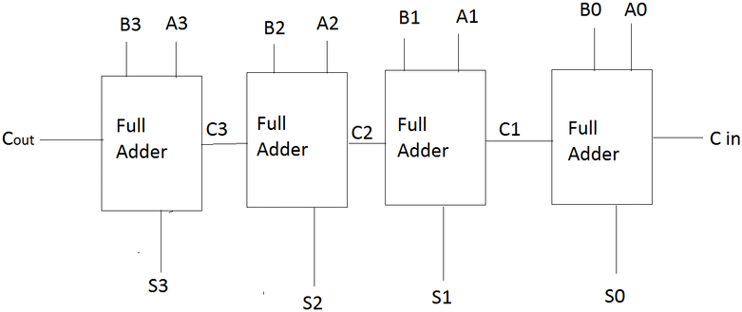

7. Labs on Loops and Generate Blocks
Lab 9: 4-to-1 MUX Using For Loop
module mux_generate (
input i0, input i1, input i2, input i3,
input [1:0] sel,
output reg y
);
wire [3:0] i_int;
assign i_int = {i3, i2, i1, i0};
integer k;
always @(*) begin
for (k = 0; k < 4; k = k + 1) begin
if (k == sel)
y = i_int[k];
end
end
endmodule
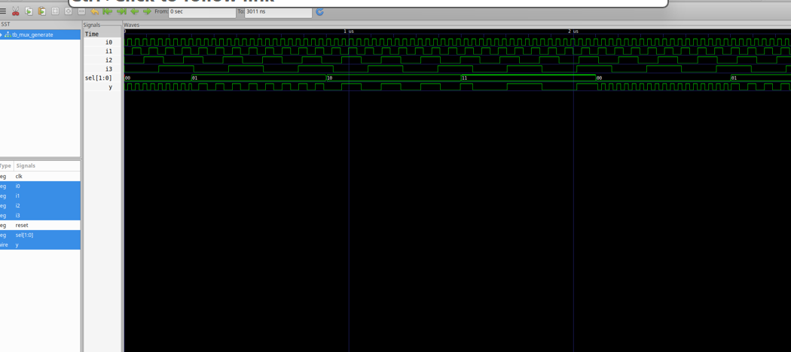
Lab 10: 8-to-1 Demux Using Case
module demux_case (
output o0, output o1, output o2, output o3,
output o4, output o5, output o6, output o7,
input [2:0] sel,
input i
);
reg [7:0] y_int;
assign {o7, o6, o5, o4, o3, o2, o1, o0} = y_int;
always @(*) begin
y_int = 8'b0;
case(sel)
3'b000 : y_int[0] = i;
3'b001 : y_int[1] = i;
3'b010 : y_int[2] = i;
3'b011 : y_int[3] = i;
3'b100 : y_int[4] = i;
3'b101 : y_int[5] = i;
3'b110 : y_int[6] = i;
3'b111 : y_int[7] = i;
endcase
end
endmodule

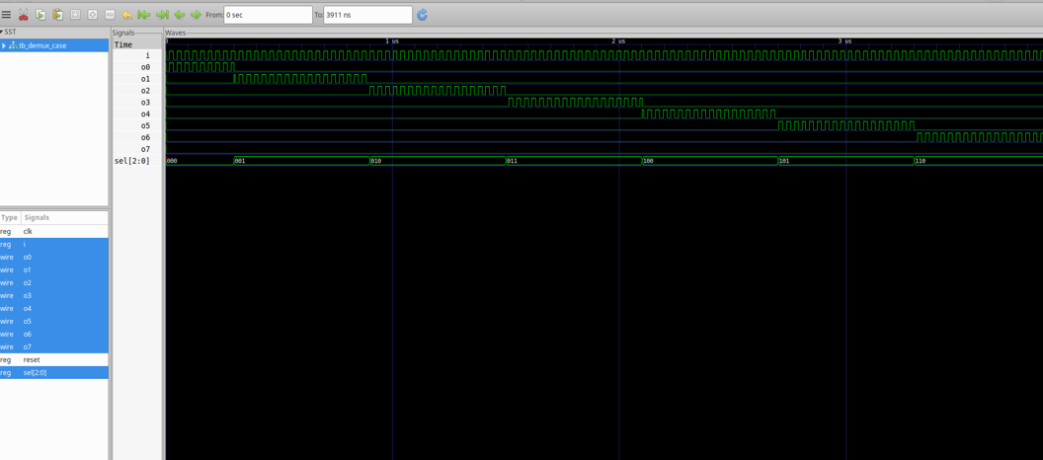
Lab 11: 8-to-1 Demux Using For Loop
module demux_generate (
output o0, output o1, output o2, output o3,
output o4, output o5, output o6, output o7,
input [2:0] sel,
input i
);
reg [7:0] y_int;
assign {o7, o6, o5, o4, o3, o2, o1, o0} = y_int;
integer k;
always @(*) begin
y_int = 8'b0;
for (k = 0; k < 8; k = k + 1) begin
if (k == sel)
y_int[k] = i;
end
end
endmodule
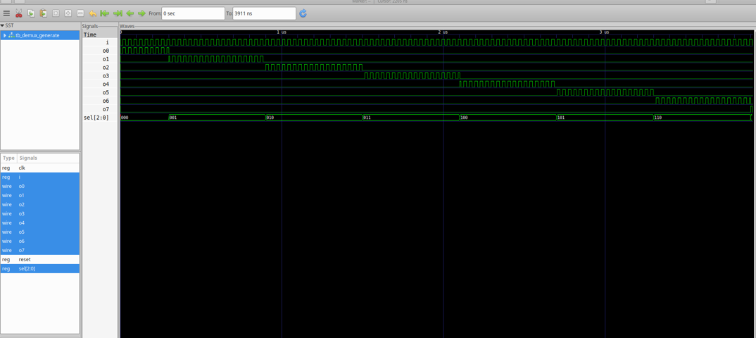
Lab 12: 8-bit Ripple Carry Adder with Generate Block
module rca (
input [7:0] num1,
input [7:0] num2,
output [8:0] sum
);
wire [7:0] int_sum;
wire [7:0] int_co;

genvar i;
generate
for (i = 1; i < 8; i = i + 1) begin
fa u_fa_1 (.a(num1[i]), .b(num2[i]), .c(int_co[i-1]), .co(int_co[i]), .sum(int_sum[i]));
end
endgenerate

fa u_fa_0 (.a(num1[0]), .b(num2[0]), .c(1'b0), .co(int_co[0]), .sum(int_sum[0]));

assign sum[7:0] = int_sum;
assign sum[8] = int_co[7];
endmodule
Full Adder Module:
module fa (input a, input b, input c, output co, output sum);
assign {co, sum} = a + b + c;
endmodule
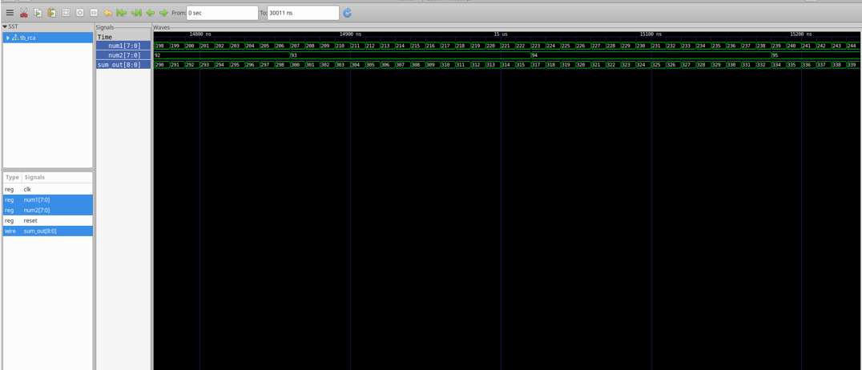
Summary
- Use complete if-else and case statements to avoid unintended latch inference.
- For loops and generate blocks are powerful for writing scalable, synthesizable code.
- Always ensure every signal is assigned in every possible execution path for combinational logic.
- Use labs to reinforce concepts with practical Verilog code and synthesis results.

